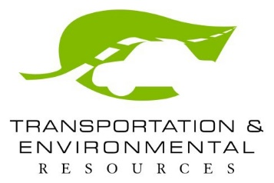
NEWS RELEASE

South East Texas Regional Planning Commission 2210 Eastex Freeway  Beaumont, Texas 77703
(409) 899-8444  www.setrpc.org

Contact: Bob Dickinson
Office Phone: (409) 899-8444 ext. 7520
Email: bdickinson@setrpc.org FOR IMMEDIATE RELEASE

Househol d Hazardo us Wast e and Scrap Tire Col lectio n E ve nt

On Saturday, May 16, 2020 from 8 a.m. to 1 p.m., the South East Texas Regional Planning Commission (SETRPC) is hosting a free Household Hazardous Waste and Scrap Tire Collection Event. The event will be held in the Bridge City Intermediate School parking lot, located at 1029 W. Roundbunch Road, in Bridge City. The event is open to all southeast Texas residents.
During this free event, the SETRPC collects items that could pose health and environmental risks if disposed of improperly. According to Bob Dickinson, Director of Transportation and Environmental Resources Division, “The average home can accumulate 100 pounds of hazardous waste in a garage or in the cabinets at home. It’s imperative that Southeast Texans take a proactive approach in properly disposing these items not only to protect their own health but the quality of life in our region.”
The SETRPC will accept household hazardous items including paints, cleaners, antifreeze, car batteries, used oil, insecticides, swimming pool chemicals, and much more. “It’s not acceptable to throw batteries, paint, or other hazardous waste in a trash can. Once these items get to the landfill, they release pollutants which contribute to poor air quality. Southeast Texans are encouraged to do their part to protect the health of their neighbors and the environment by properly disposing of their hazardous waste during this free collection event,” says Shanna Burke, SETRPC Executive Director.
The SETRPC will also collect scrap tires at no charge for the first eight tires. A cash disposal fee of
$1.00 is required for each additional tire - oversized tires are not accepted. Materials not accepted during this event include; electronics, appliances, oversized tires, explosives, ammunition, garbage, scrap metal, mercury, smoke detectors, exit signs, medical waste and medications/pharmaceuticals.
The HHW event is a program of the SETRPC through a grant provided by the Texas Commission on Environmental Quality.
For more information about items accepted during this event call 409 899-8444 ext. 7520.

House hold Haza rdous W as te a nd
Sc ra p Tire Colle c tion E ve nt

Saturday, May 16, 2020
8 a.m.-1 p.m.
Bridge City Intermediate School Parking Lot
1029 W. Roundbunch Road Bridge City, Texas

